### **Reaching out to a recruiter**

**Template**

*Hello {{firstName}},*

*I saw that you are a recruiter at {{company}}.*

*I am a {{occupation}} with {{number}} years of experience in the {{industry}} industry, currently seeking new opportunities.*

*I’d like to connect and chat to see if my background fits any of your openings.*

**Example**

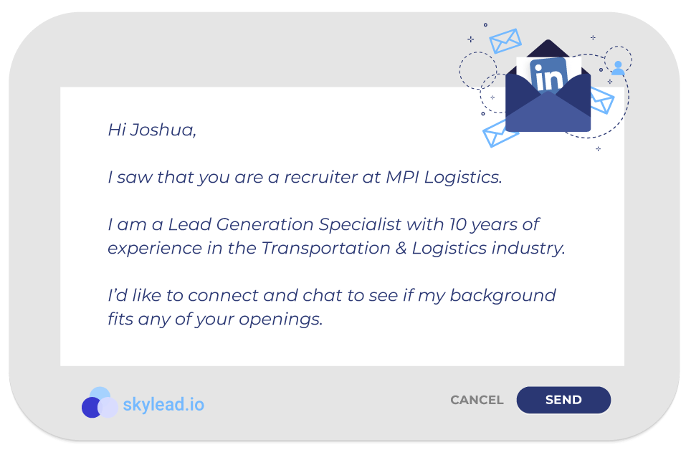

**OR**

**Template**

*Hello {{firstName}},*

*I see that you’re the recruiter in charge of the {{occupation}} position at {{company}}.*

*I am very interested in applying but would like to ask you a few questions first.*

*Let’s connect.*

**Example**

